## **Networking Fundamentals Homework: Rocking your Network!**

You have just been hired by RockStar Corporation as a network security analyst.

* RockStar Corp has recently built a new office in Hollywood, California. You are tasked with completing a **network vulnerability assessment** of the office.
* You will complete several steps in order to analyze the Hollywood network and then provide RockStar Corp a summary of your findings.
* RockStar Corp is also concerned that a hacker may have infiltrated their Hollywood office. You will need to determine if there is anything suspicious in your findings.

### **Files Required**

RockStar Corp has provided you with:

* A list of their network assets: Rock Star Server List
* Instructions to scan their network.

### **Your Goal**

You will follow instructions to work through four phases of the network assessment. For each phase, include the following:

* The steps and commands used to complete the tasks.
* A summary of your findings for each testing phase.
* Any network vulnerabilities discovered.
* Findings associated with a hacker.
* Recommended mitigation strategy.
* Document the OSI layer where the findings were found.

### **Topics Covered in Your Assignment**

* Subnetting
* CIDR
* IP Addresses
* fping
* OSI Model and OSI Layers
* Protocols
* Ports
* Wireshark
* PCAP Analysis
* DNS
* HTTP
* ARP
* Syn Scan
* TCP
* nslookup
* Network Vulnerability Assessments
* Network Vulnerability Mitigation

### **Network Vulnerability Assessment Instructions**

Please note that you will be using your Vagrant virtual machine for this homework.

### **Phase 1: *"I'd like to Teach the World to Ping"***

You have been provided a list of network assets belonging to RockStar Corp. Use fping to ping the network assets for only the Hollywood office.

* Determine the IPs for the Hollywood office and run fping against the IP ranges in order to determine which IP is accepting connections.

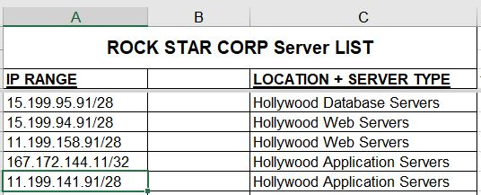

Open browser to <https://ipaddressguide.com/cidr>

Enter each range in CIDR format, and get the first and last addresses to use for fping

Hollywood Database Servers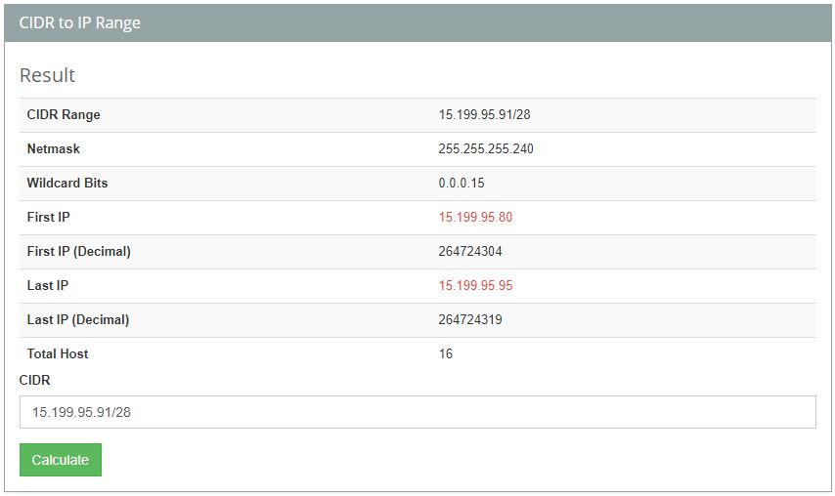

Hollywood Web Servers (first)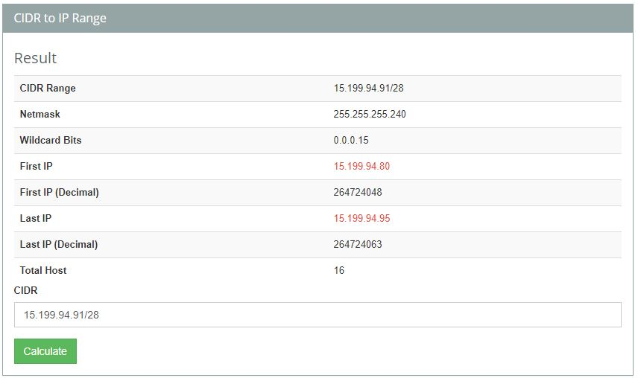

Hollywood Web Servers (second)

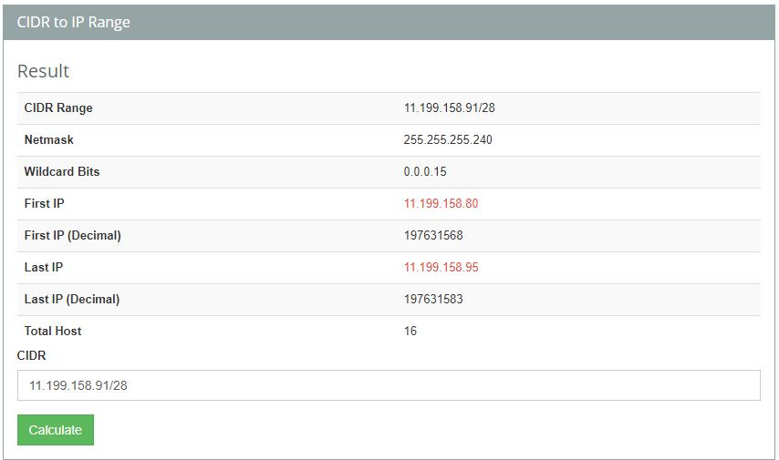

Hollywood Application Servers (first)

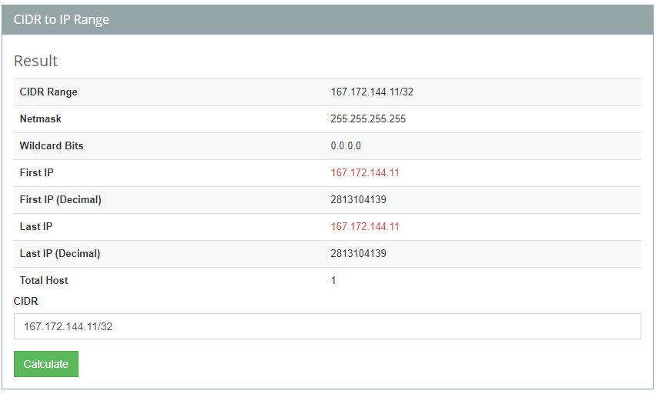

Hollywood Application Servers (second)

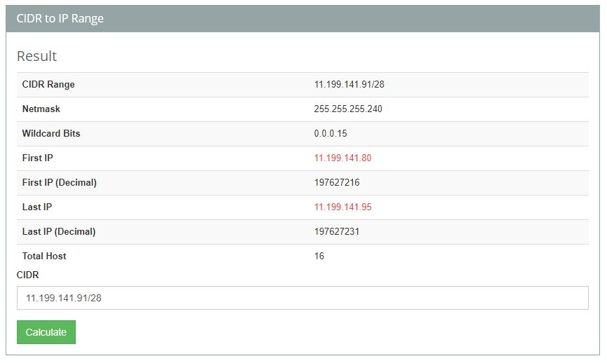

* RockStar Corp doesn't want any of their servers, even if they are up, indicating that they are accepting connections.  
  + Use fping <IP Address> and ignore any results that say "Request timed out".
  + If any of the IP addresses send back a Reply, enter Ctrl+C to stop sending requests.
  + By the time the output is displayed, the command has already completed running, thus using Ctrl+C is not applicable.
* Create a summary file in a word document (or use this document) that lists out the fping command used, as well as a summary of the results.

15.199.95.91/28: not accepting connections at OSI Network Layer 3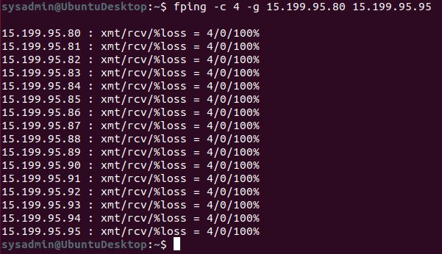

15.199.94.91/28: not accepting connections at OSI Network Layer 3

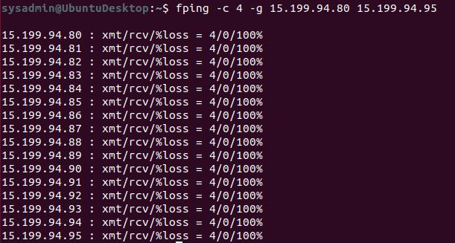

11.199.158.91/28: not accepting connections at OSI Network Layer 3

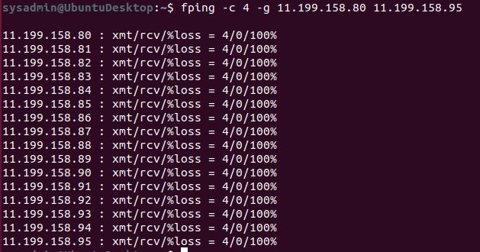

167.172.144.11/32: accepting connections at OSI Network Layer 3

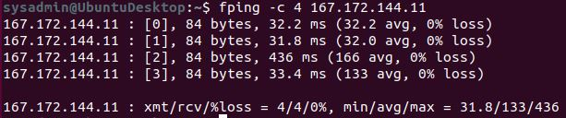

11.199.141.91/28: not accepting connections at OSI Network Layer 3

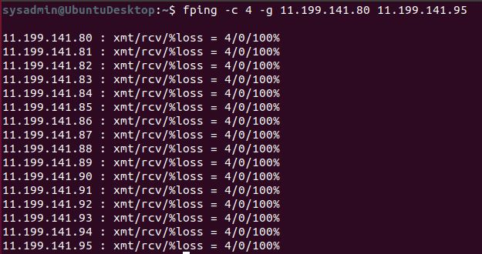

* Your summary should determine which IPs are accepting connections and which are not.
* Also indicate at which OSI layer your findings are found.

### **Phase 2: *"Some Syn for Nothin`"***

With the IP(s) found from Phase 1, determine which ports are open:

* You will run a SYN SCAN against the IP accepting connections. See **SYN SCAN Instructions** below.
* Using the results of the SYN SCAN, determine which ports are accepting connections.
* Add these findings to the summary and be sure to indicate at which OSI layer your findings were found.

#### **SYN SCAN Instructions**

What is **Nmap**?

* **Nmap** is a free networking scanning tool available for Linux distributions.
* Security professionals use Nmap to determine the devices running on a network, as well as finding open ports to determine potential security vulnerabilities.
* Nmap has many capabilities and commands that can be run. Here is a cheat sheet for reference:<https://www.stationx.net/nmap-cheat-sheet/>.

For this activity, we will specifically focus on the Nmap capability of running a SYN SCAN.

* We have already covered that a SYN SCAN is an automated method to check for the states of ports on a network, Nmap is simply a tool that can automate this task.

To run a SYN SCAN:

* Open up the terminal within your Linux machine.
* The command to run a SYN SCAN is nmap -sS <IP Address>.  
  + For example, if you wanted to run a SYN SCAN against the server IP of 74.207.244.221, you would run nmap -sS 74.207.244.221 and press enter.
  + This will scan the most common 1000 ports.

After this runs for several minutes, it should return a similar result that depicts the state of the ports on that server:  
  
 Starting Nmap 7.70 ( https://nmap.org ) at 2019-08-14 11:51 EDT

Nmap scan report for li86-221.members.linode.com (74.207.244.221)

Host is up (1.4s latency).

Not shown: 988 closed ports

PORT STATE SERVICE

22/tcp open ssh

25/tcp filtered smtp

110/tcp open pop3

113/tcp filtered ident

135/tcp filtered msrpc

139/tcp filtered netbios-ssn

143/tcp open imap

445/tcp filtered microsoft-ds

465/tcp open smtps

587/tcp open submission

993/tcp open imaps

* 995/tcp open pop3s
* The results show the port number / TCP / UDP , the state of the port, and the service / protocol for the ports that are either open or filtered (stopped by a firewall).
* Closed ports are not shown, indicated on the line: Not shown: 988 closed ports.
* For the purpose of this exercise, document which ports are open on the RockStar Corp server, and which OSI layer SYN scans run on.

$ sudo nmap -sS 167.172.144.11

Only port 22/tcp is open.

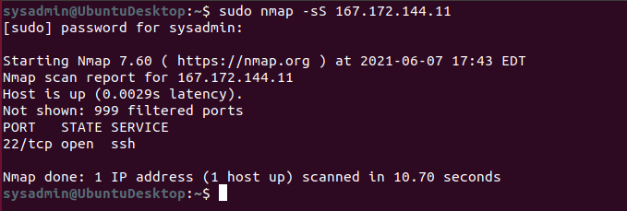

### **Phase 3: *"I Feel a DNS Change Comin' On"***

With your findings from Phase 2, determine if you can access the server that is accepting connections.

* RockStar typically uses the same default username and password for most of their servers, so try this first:  
  + **Username:** jimi
  + **Password:** hendrix

$ ssh jimi@167.172.144.11

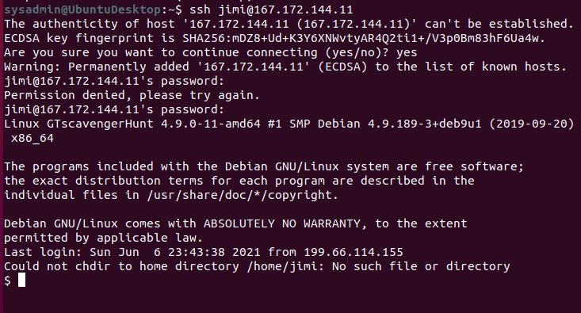

* Try to figure out which port/service would be used for remote system administration, and then using these credentials, attempt to log into the IP that responded to pings from **Phase 1**.

RockStar Corp recently reported that they are unable to access rollingstone.com in the Hollywood office. Sometimes when they try to access the website, a different, unusual website comes up.

* While logged into the RockStar server from the previous step, determine if something was modified on this system that might affect viewing rollingstone.com within the browser. When you successfully find the configuration file, record the entry that is set to rollingstone.com.

$ cat /etc/hosts | more

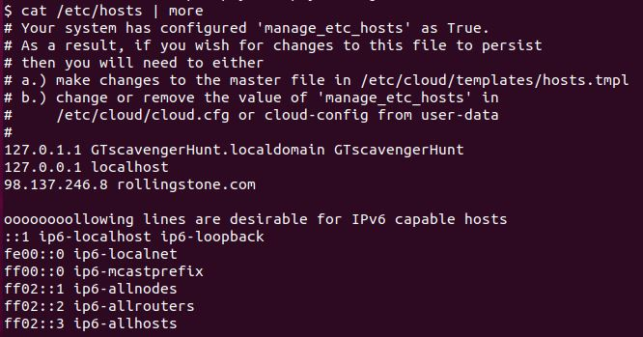

* Terminate your ssh session to the rollingstone server, and use nslookup to determine the real domain of the IP address you found from the previous step.  
  + **Note**: **nslookup** is a command line utility that can work in Windows or Linux Systems. It is designed to query Domain Name System records. You can use PowerShell or MacOS/Linux terminal to run nslookup.
  + To run **nslookup**, simply enter the following on the command line:  
      
     nslookup <IP Address> to find the domain associated to an IP address  
      
     OR  
      
     nslookup <domain name> to find the IP address associated to a domain

$ nslookup 98.137.246.8  
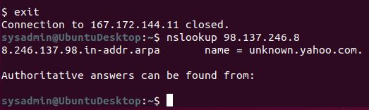

Nslookup uses Domain Name Service (DNS) which work on OSI Application Layer 7.

* + You'll know you found the right domain if it begins with media-.
* Add your findings to your summary and be sure to indicate which OSI layer they were found on.

### **Phase 4: *"ShARP Dressed Man"***

Within the RockStar server that you SSH'd into, and in the same directory as the configuration file from **Phase 3**, the hacker left a note as to where he stored away some packet captures.

* View the file to find where to recover the packet captures.
* These are packets that were captured from the activity in the Hollywood Office.
* Use Wireshark to analyze this pcap file and determine if there was any suspicious activity that could be attributed to a hacker.  
  + **Hint**: Focus on the ARP and HTTP protocols. Recall the different types of HTTP request methods and be sure to thoroughly examine the contents of these packets.
* Add your findings in your summary and be sure to indicate at which OSI layer they were found.

### **Your Submission: *"Its the End of the Assessment as We Know It, and I Feel Fine"***

#### **Guidelines for your Submission:**

Provide the following for each phase:

* List the steps and commands used to complete the tasks.
* List any vulnerabilities discovered.
* List any findings associated to a hacker.
* Document the mitigation recommendations to protect against the discovered vulnerabilities.
* Document the OSI layer where the findings were found.

For example:

**Phase 1**

* Determined the IP ranges to scan were 1.1.1.1 and 2.2.2.2, then ran fping against 1.1.1.1 and 2.2.2.2.  
  + Used the following commands to run fping:  
    - fping 1.1.1.1
* Determined a potential vulnerability that IP 1.1.1.1 is responding.  
  + Since RockStar Corp doesn't want to respond to any requests, this is a vulnerability.
* Recommend to restrict allowing ICMP echo requests against IP 1.1.1.1 to prevent successful responses from PING requests.
* This occurred on the network layer as Ping uses IP addresses and IPs are used on the Network Layer.